Question 4

|  |
| --- |
|  |

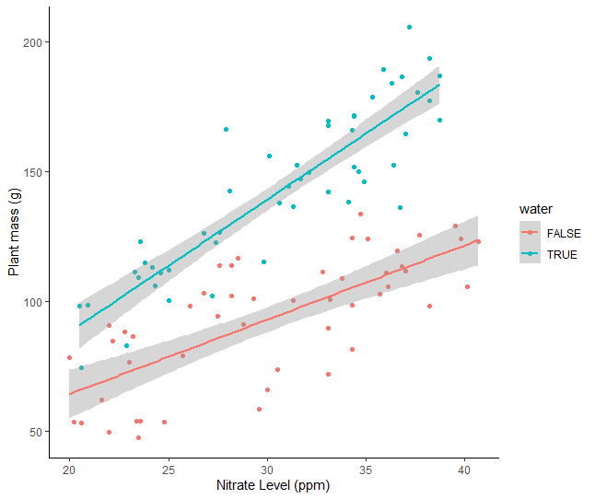Question 6

Question 8

|  |
| --- |
|  |